**Cyber Girls - Documentation**

This webpage is part of the Cyber Girls program, which aims to empower women in the field of cybersecurity. The page is structured to provide an overview of the program's offerings, a navigation menu, and contact information.

Page Structure

**1. Header Section**

* Logo: A shield icon with the text "Cyber Girls."
* Navigation Menu:
  + Home
  + Who We Are
  + Program Details
  + Success Stories
  + Mentor Profiles
  + Enrollment
  + Resource Hub
  + Contact Us
* Login Button: Positioned on the far right of the header for user authentication.

2. **Hero Section**

• A visually captivating background image featuring a technology theme (a cybernetic design with bright colors).

• This section does not include text or buttons directly overlaid on the image.

**3. What We Offer Section**

* Title: "What We Offer" centered above three cards.
* Cards:

**1. Training Programs:**

* Icon: A monitor with code brackets.
* Text: "Comprehensive cybersecurity training designed for women."

2. **Mentorship:**

* + Icon: Two people.
  + Text: "Connect with experienced professionals in the field."

3. Certification:

Icon: A certification seal.

Text: "Industry-recognized certifications and credentials."

________________________________________

4. Footer Section

* Subsections:
  + Cyber Girls:
* Tagline: "Empowering the future of cybersecurity."
  + Contact Us:
* Email: contact@plutoways.org
* Phone: (+232) 798585406
* Address: "40 Versace Road opposite Hell's Gate."
  + Social Media Links:
* Icons for Facebook, Twitter, LinkedIn, and Instagram.
* Copyright Notice: "© 2024 Cyber Girls. All rights reserved."

________________________________________

Styling

1. Color Scheme:
   1. Dark blue for the header and footer.
   2. White and light gray for the main body.
   3. Blue accents for icons and text emphasis.
2. Typography:
   1. Clean sans-serif font.
   2. Bold headers and legible body text.
3. Card Design:
   1. White background with subtle shadows.
   2. Rounded corners for a modern look.

________________________________________

Functionality

• Navigation Menu: Links to respective sections or pages.

• Login Button: Redirects users to the login page.

• Social Media Links: Opens respective platforms in new tabs.

• Contact Details: Allows users to initiate calls, emails, or map navigation.

Home Page

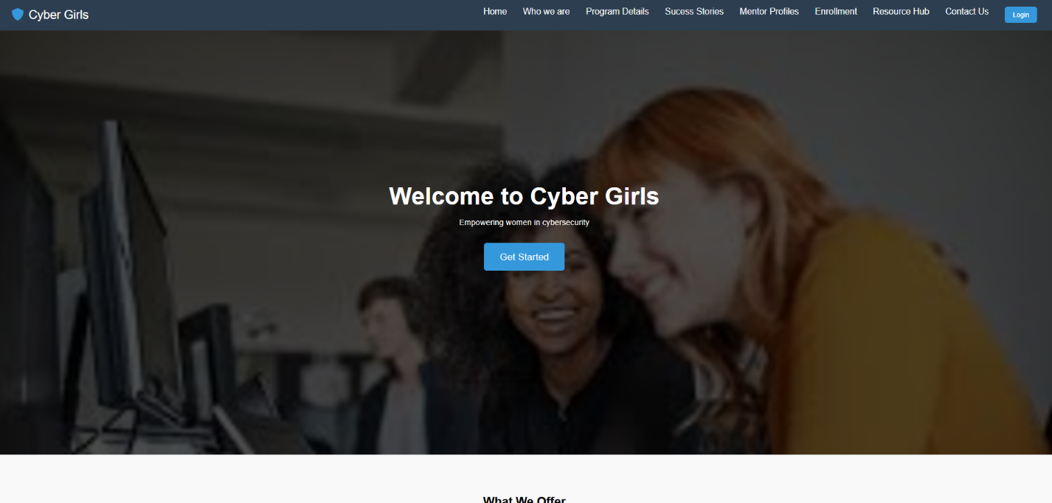

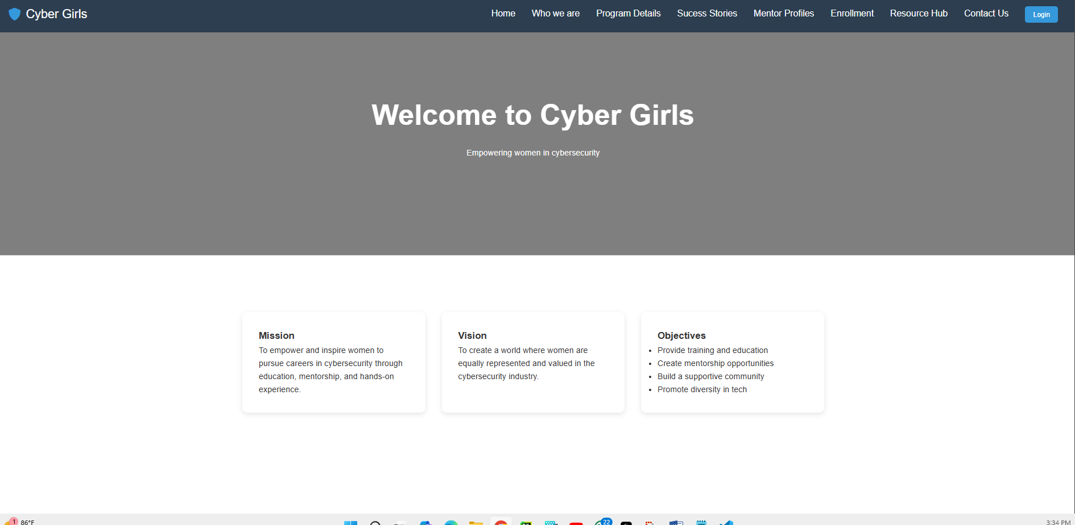

Who we are page

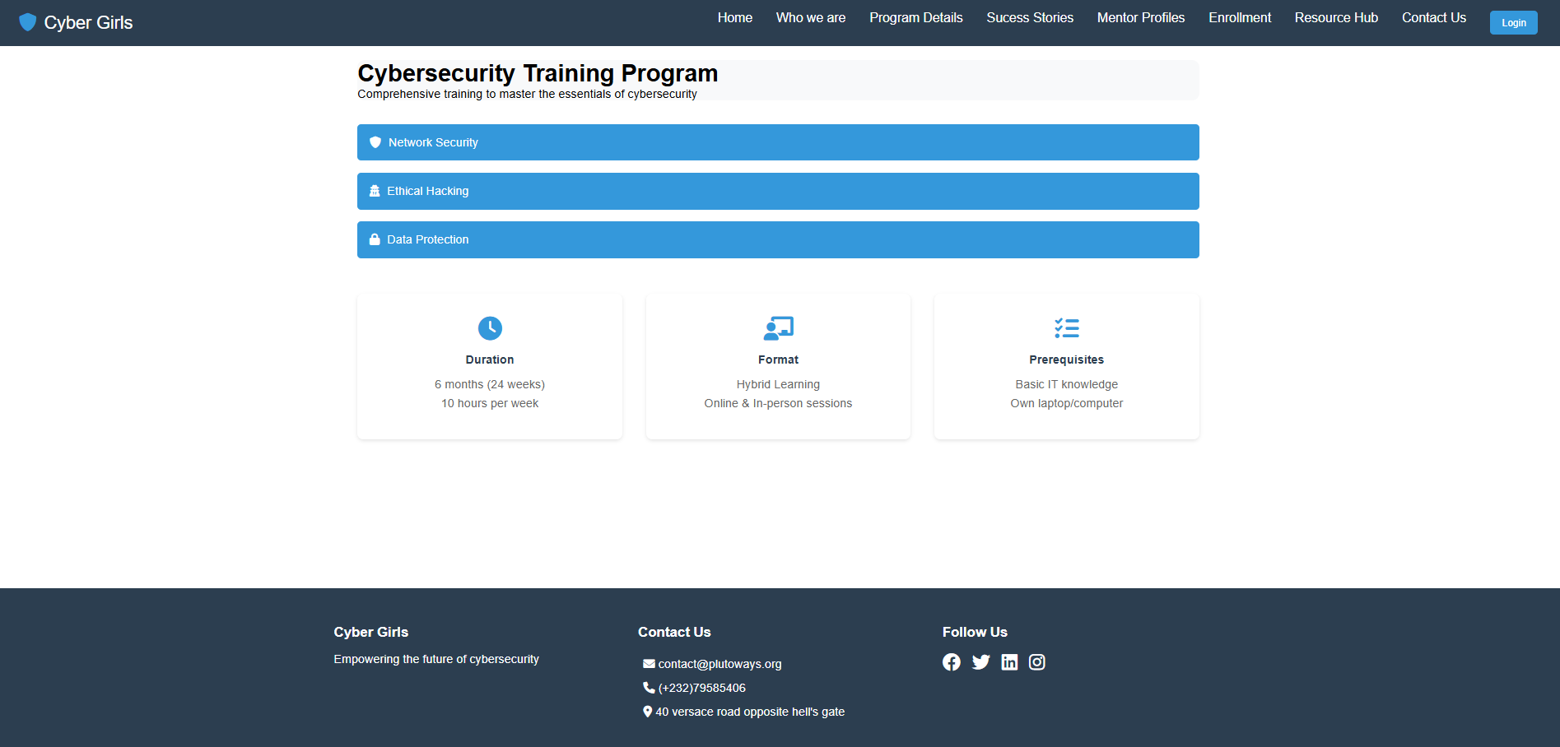

Program details

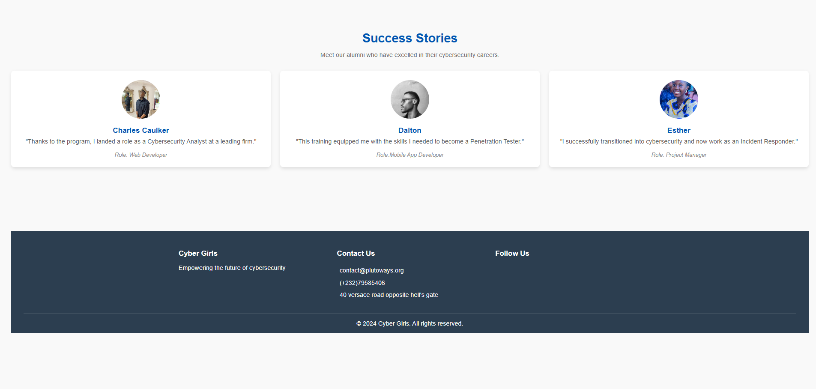**Success stories page**

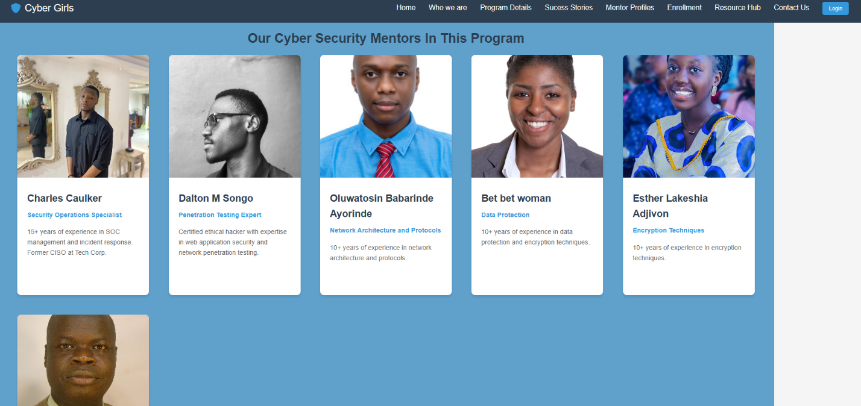

Mentorship profiles page

Resource Hub

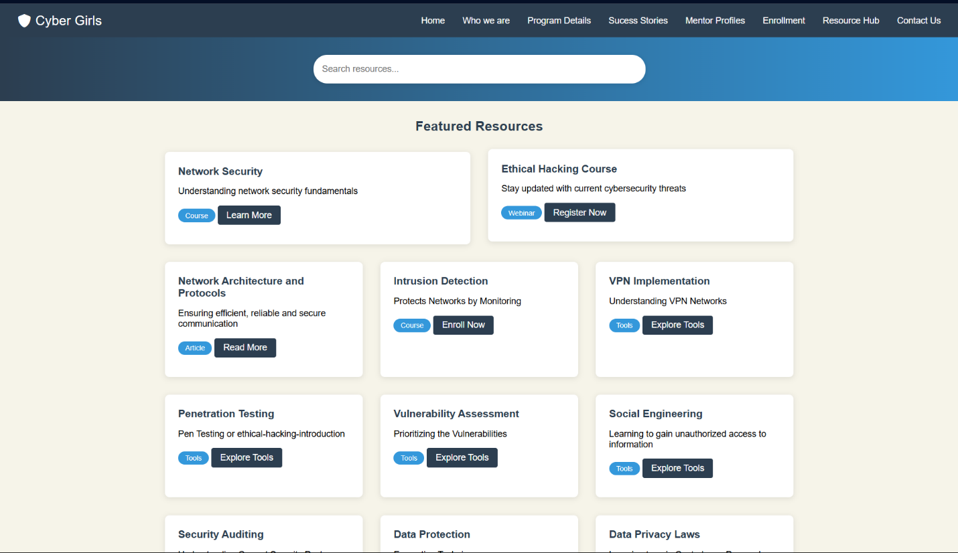

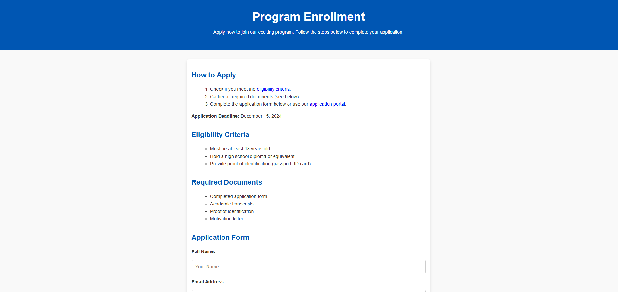

Enrollment form

